Multiple choice section

Question 1 [8.2]

Which of the following consists of one acute angle and one obtuse angle that are supplementary?

A 20° and 160° B 90° and 90° C 180° and 180° D 60° and 360°

Question 2 [8.3]

The complement of 52° is:

A 128° B 52° C 42° D 38°

Question 3 [8.6]

Which of the following statements is true for all equilateral triangles?

A All 3 angles are equal B All 3 sides are equal in length

C Each angle is equal to 60° D All of the above

Question 4 [8.3]

Three angles make a revolution. The angles are 26°, 178° and x. The value of x is:

A 26° B 178° C 156° D 182°

Question 5 [8.6]

The triangle is: 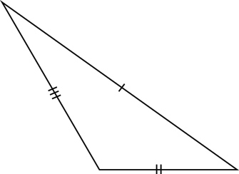

A scalene and obtuse angled B right-angled

C acute angled and isosceles D scalene and acute angled

Question 6 [8.4]

Alternate angles are

A always equal.

B only equal when the traversal intersects two lines that are parallel.

C never equal unless both are located on the same side of the traversal.

D always complementary.

Question 7 [8.5]

A polygon with 11 sides is called a:

A octagon B nonagon

C decagon D undecagon

Question 8 [8.7]

The quadrilateral shown is a:

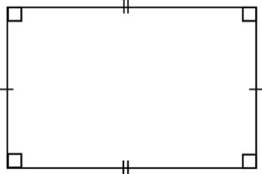

A rhombus B rectangle

C parallelogram D B and C are both true

Question 9 [8.2]

The type of angle is a:

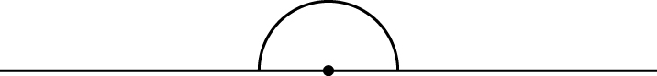

A reflex B right angle

C straight D obtuse

Question 10 [8.4]

Angles x and y are co-interior angles.   
If y = 37°, x is equal to:

A 37° B 143° C 53° D 323°

Multiple-choice total marks: ____ / 10

Short answer section

Question 11 3 marks [8.1, 8.2]

Use a protractor to measure the size of the following angles, correct to the nearest degree.

(a) (b)

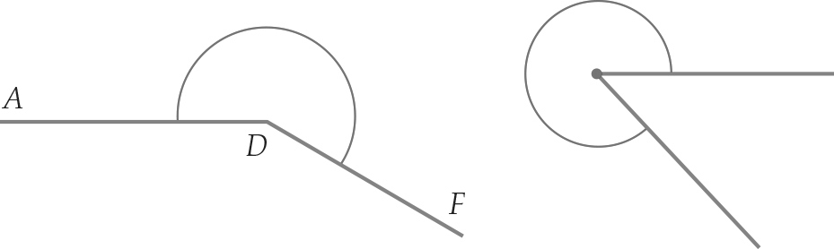

(c) Name the angle in part (a).

Question 12 2 marks [8.1]

Draw an angle of 147°

Question 13 5 marks [8.2]

For the diagram below:

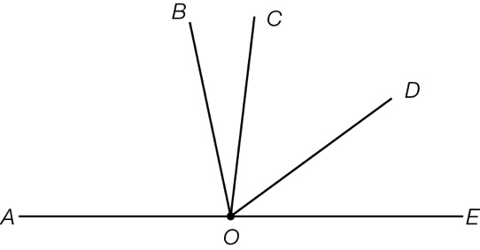

(a) list all acute angles, other than ∠*BOC* ____________________

(b) list all obtuse angles ____________________

(c) a straight angle ____________________

Question 14 5 marks [8.3]

Find the size of the angle x.

(a)   
 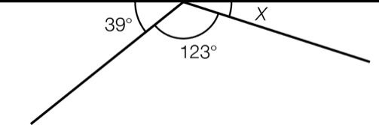

(b)   
 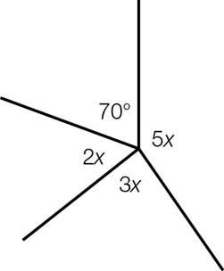

Question 15 2 marks [8.4]

Find the size of the angle marked x, giving reasons.

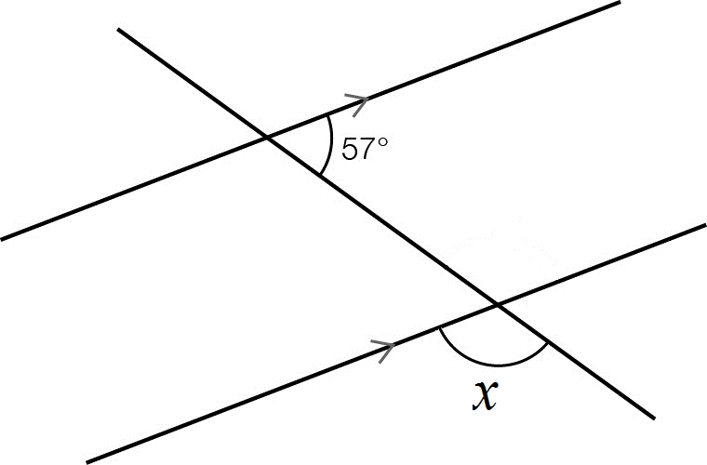

Question 16 4 marks [8.5]

Name the polygons in this pattern.

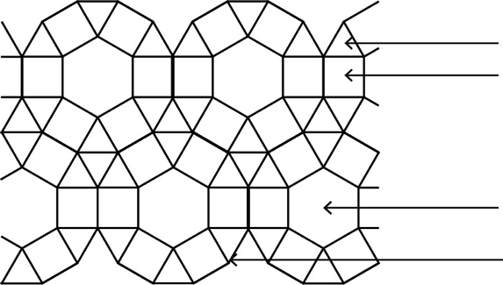

Question 17 4 marks [8.6]

Calculate the value of the pronumeral.

(a)   
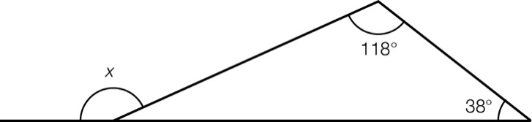

(b)   
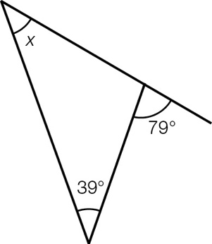

Question 18 3 marks [8.7]

A kite has a top angle measuring 115° and a bottom angle measuring 31°. Find the size of the other two angles. Give reasons.

Question 19 3 marks [8.7]

An angle in a parallelogram measures 55°. Draw a diagram and mark in the size of all the angles.

The diagram does not need to be to scale.

Question 20 4 marks [8.8]

Using only a compass, a ruler and a pencil, construct a triangle ABC with a line AB = 4 cm as the base of the triangle. ∠BAC needs to be 30° and ∠ABC must be 60°. Leave all construction lines.

Question 21 4 marks [8.8]

Using only a compass, a ruler and a pencil, construct an angle of 135°. Leave all construction lines.

Question 22 4 marks [8.6]

Find the angle marked x, giving reasons.

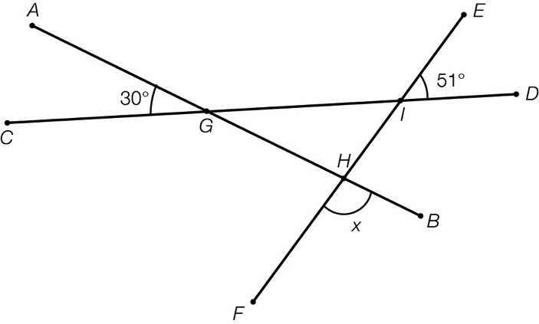

Short answer total:_______ /43

Extended answer section

Question 23 6 marks [8.6]

What is the value of the angle d?

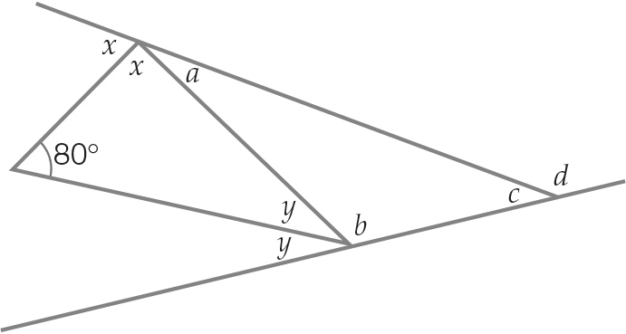

Question 24 3 marks [8.6]

What is the value of the angle x?

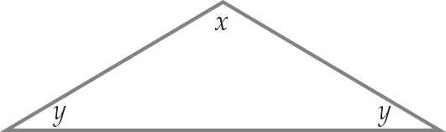

Question 25 5 marks [8.3]

In the following diagram ∠EGB = 142° and ∠DGF = 119°. What is the size of ∠AGC?

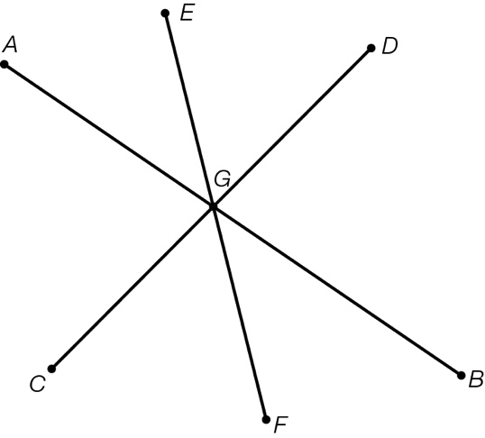

Question 26 5 marks [8.5]

Hannah is making a quilt and needs to make a regular dodecagon template.

(a) Draw a diagram to represent the template (i.e. the dodecagon).

(b) What is the sum of the interior angles of the dodecagon?

(c) What is the size of one interior angle of the dodecagon?

Extended answer total:_______ /19

TOTAL test marks: _______ / 82